**Session 1**

Revision of Python Syntax Level 1

# Session 1

1. Setting up Jupyter Notebook / VS code

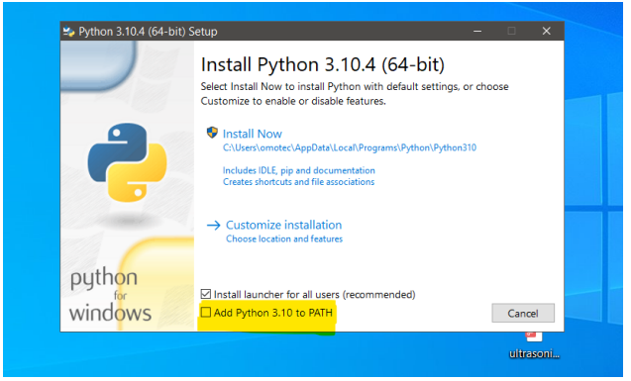

1. print() function
2. input() function
3. Variables

# Session 2

* Python data types
  + Basic data types (int, float, and bool)

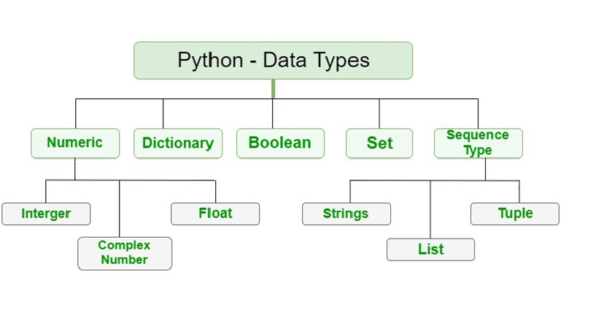

* type() function
* Strings
* Type casting
* Lists

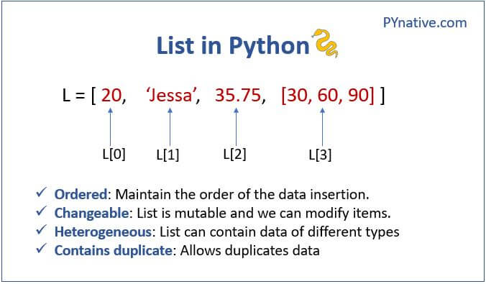

* String and list indexing

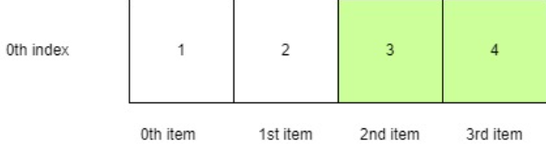

* Indexing and Slicing

# Session 3

* len() function
* Built-in list methods
* Mutable vs Immutable data types
* Operators in Python

Arithmetic Operator

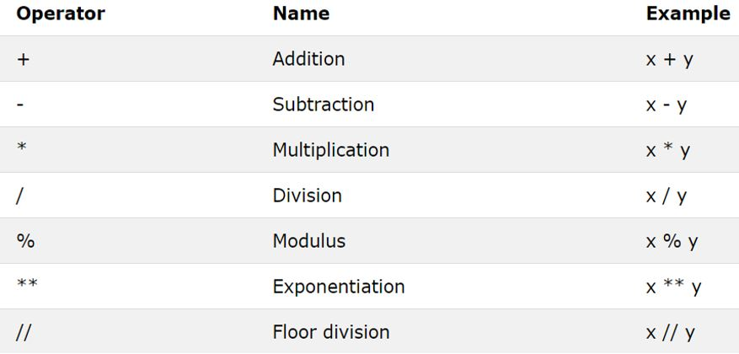

Assignment Operator

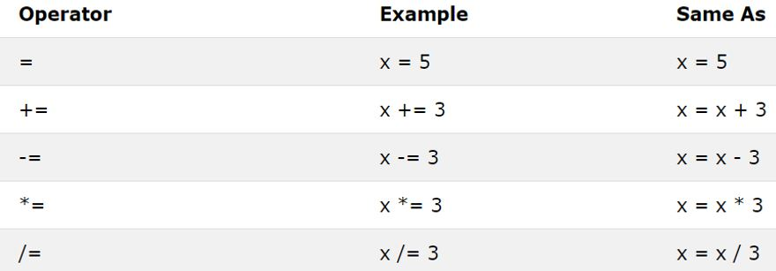

Logical Operator

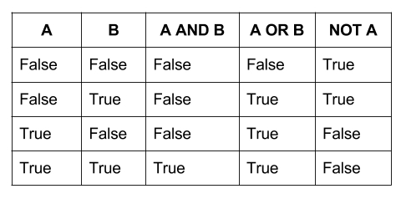

Comparison Operator

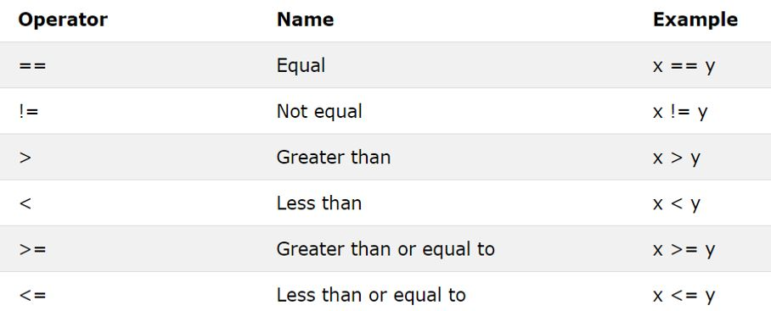

Bitwise Operator

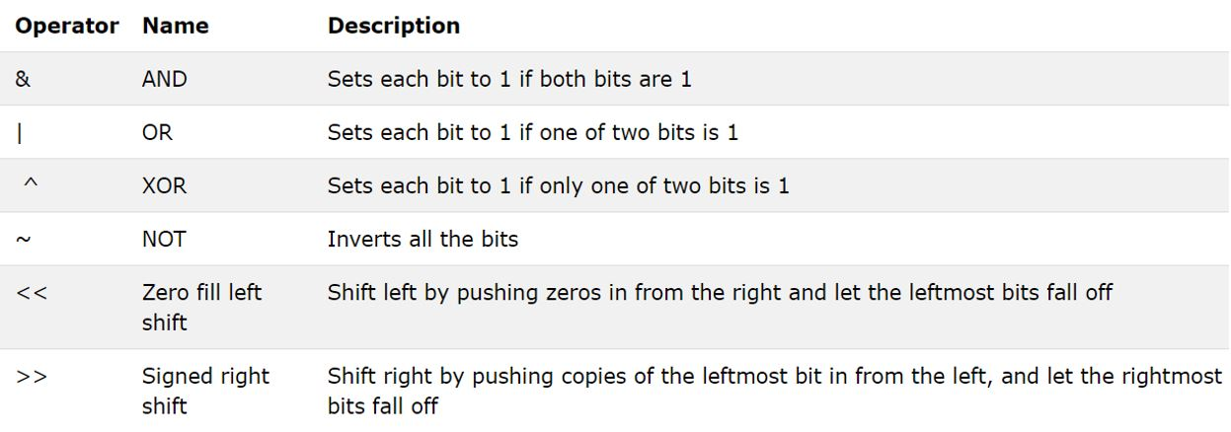

Operator Precedence

# Session 4

* If statement
* If else statements
* If elif else statements
* Built-in String methods
* Mutable vs Immutable data types

# Session 5 - Loops

1. Importance of Loops in Programming
2. For loop
3. range() function
4. While loop
5. Loop control statement

# Session 6 - Functions

1. Introduction to Functions

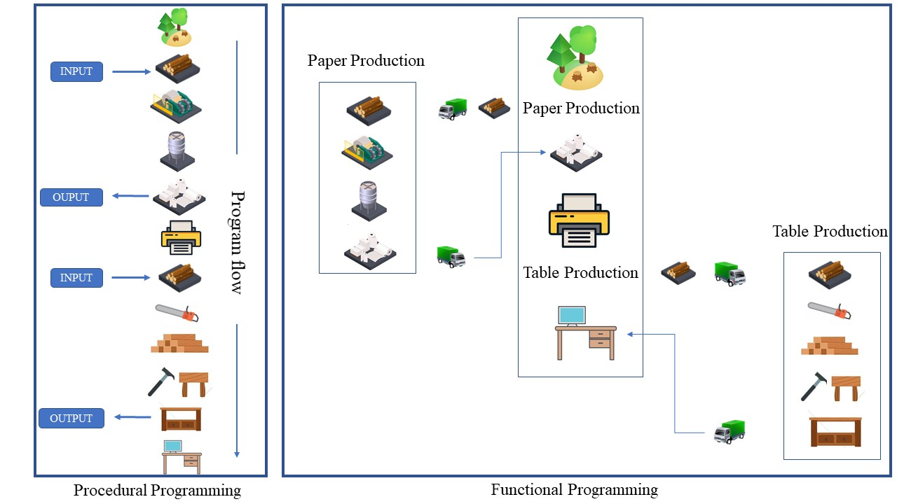

1. Function definition
2. Passing in arguments

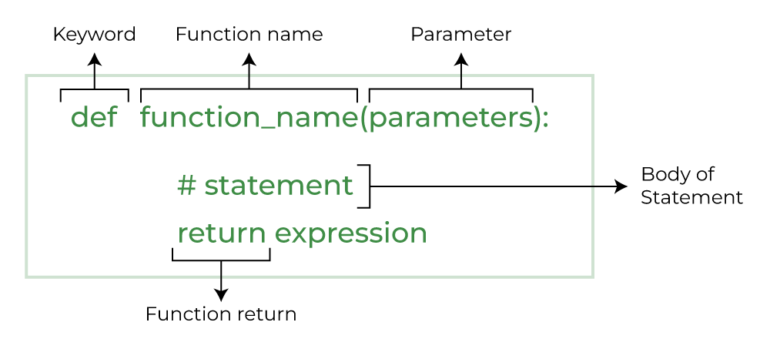

1. Return keyword
2. Scope

# Session 7

* The Tic Tac Toe game

# Session 8

1. Tuples

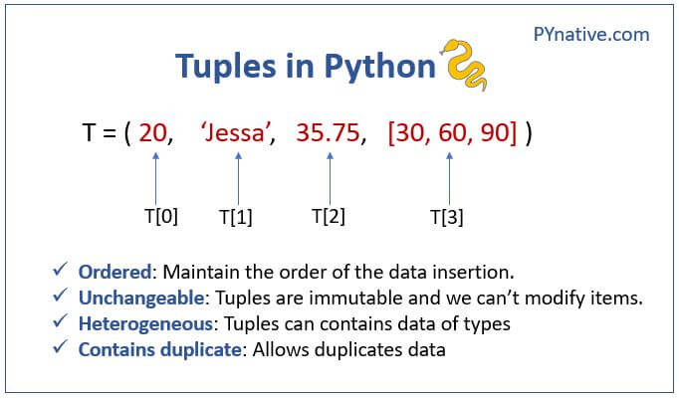

1. Built-in Tuple Methods
2. Dictionary

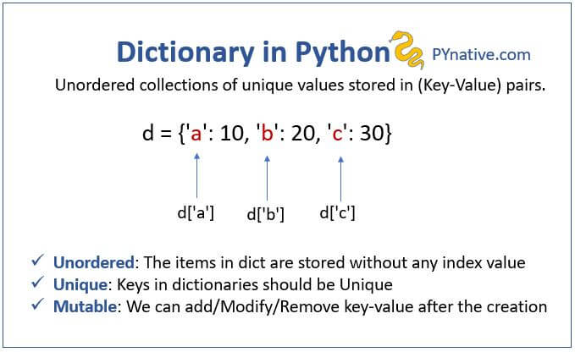

1. Built-in Dictionary Methods

 5. Sets

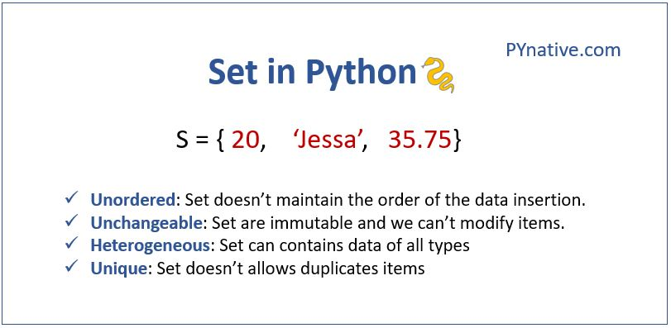

6. Built-in Set Methods

# Session 9 - Modules

1. Types of modules
   * Built-in Modules
   * Installed Modules
   * user created modules
2. Getting started with the PyAutoGui Module

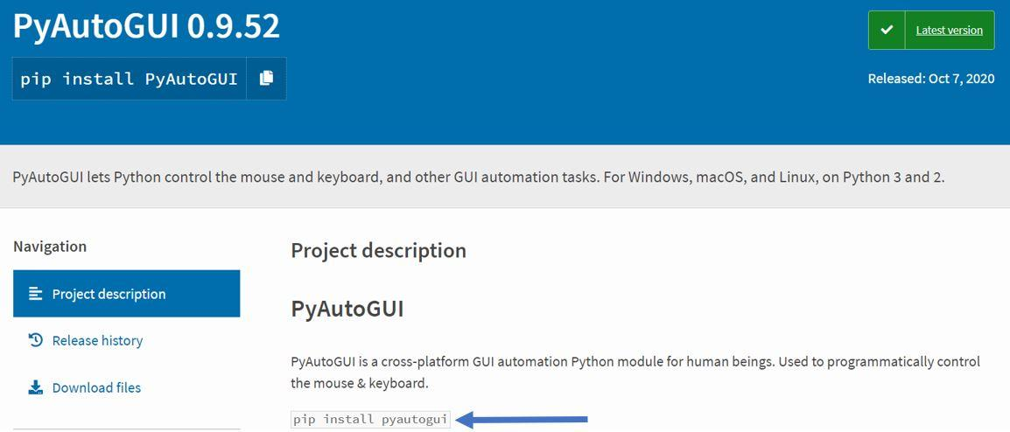

How to use the pygame module

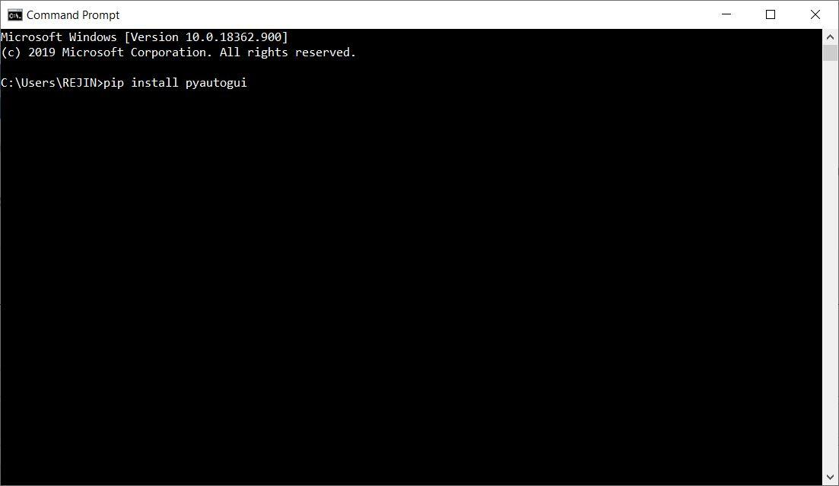

1. Creating simple Modules

# Session 10

1. Reading Files
2. Writing files
3. Reading CSV files

